Week 5 Assignment

Muhammad Sharif Miya
Westcliff University
PRG 200: Programming in the cloud
Professor Pandey
August 2, 2026
Code 1
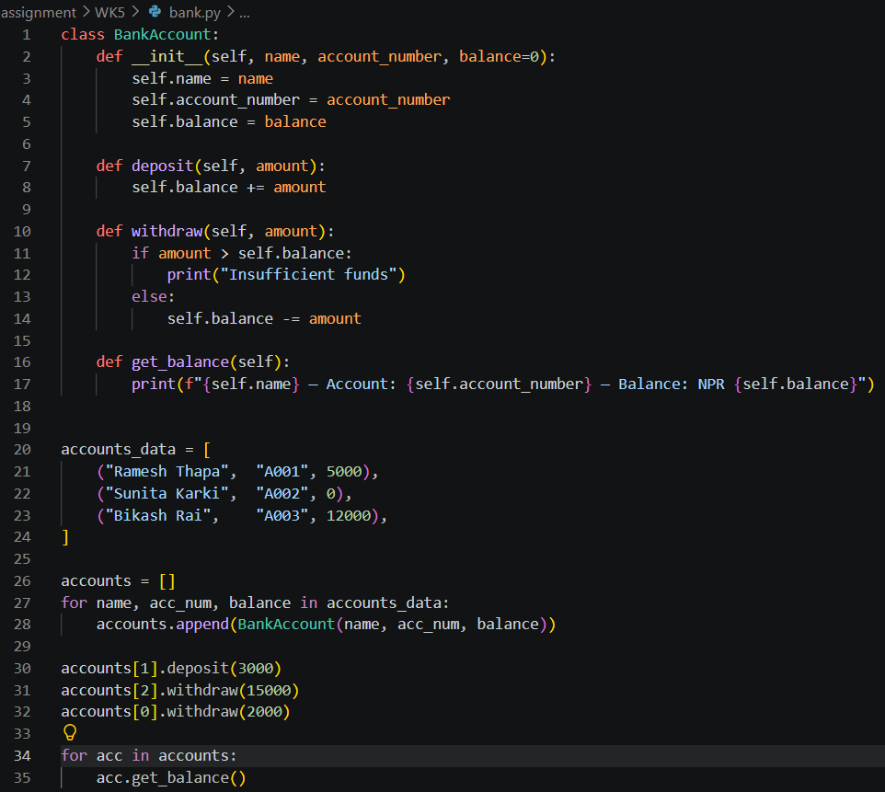

Output
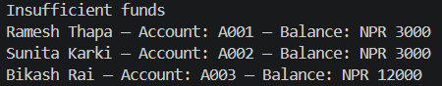
Code 2
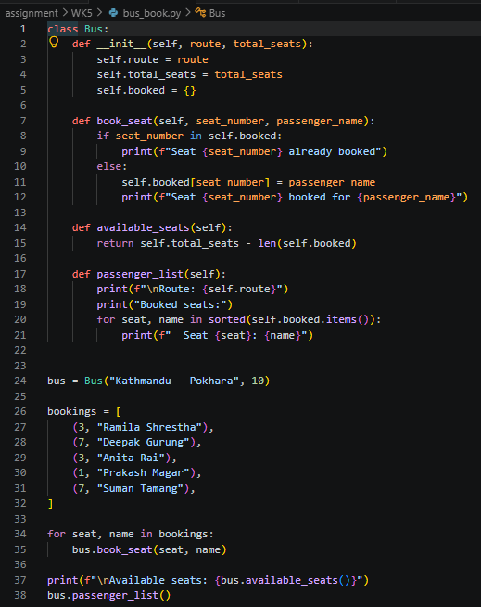

Output
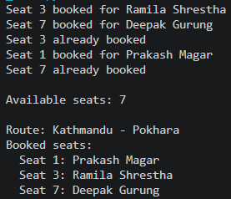
Code 3
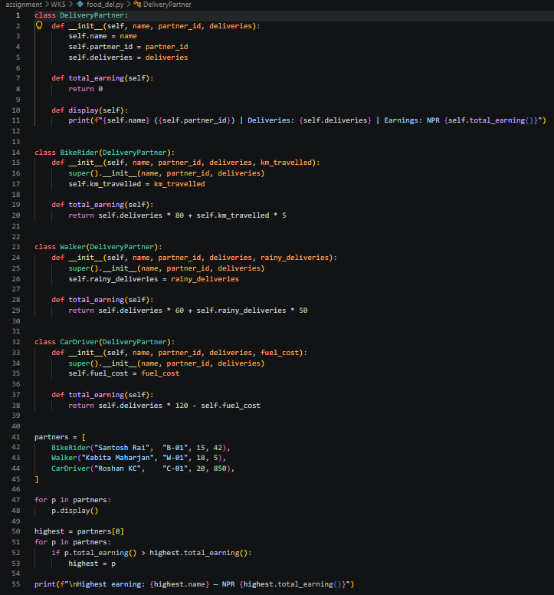

Output
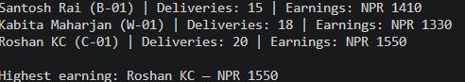

Code 4
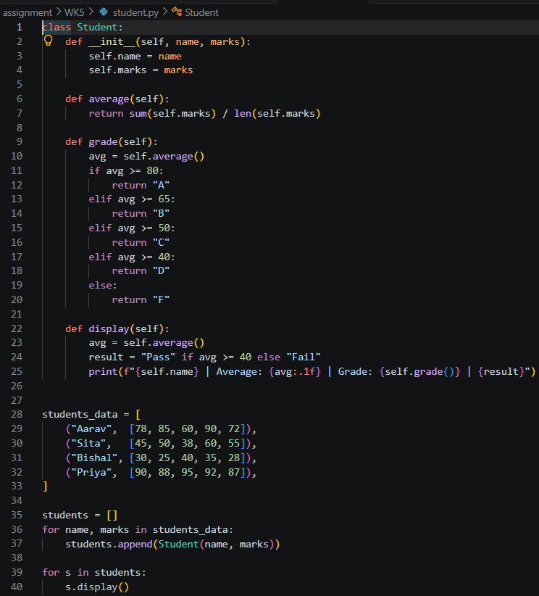
Output
